Q1. ON TABLES
I.
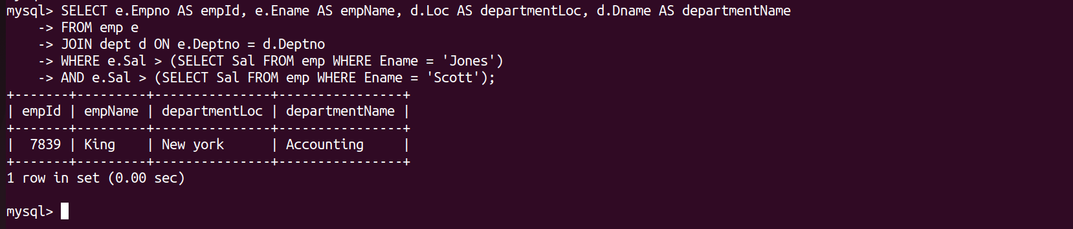
II.
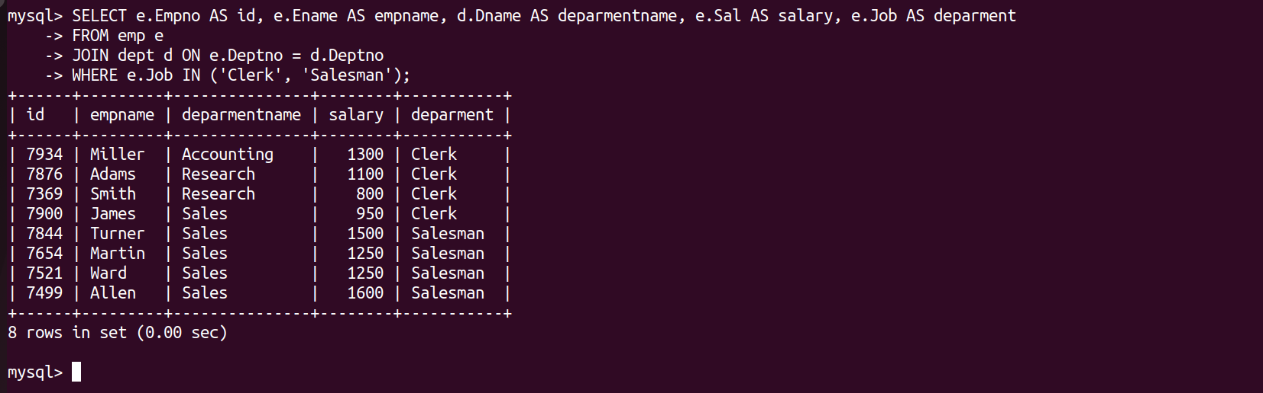
III.
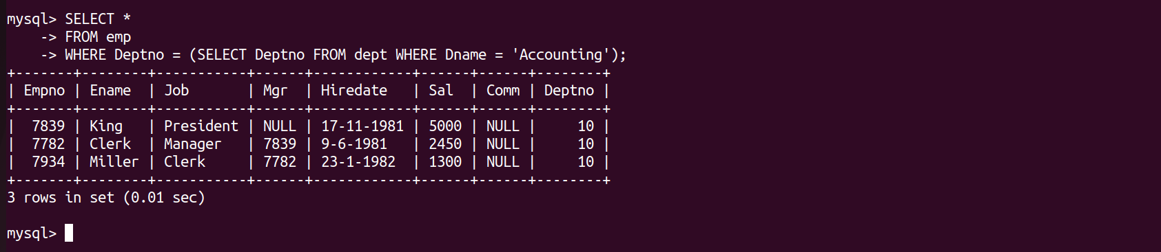
IV.
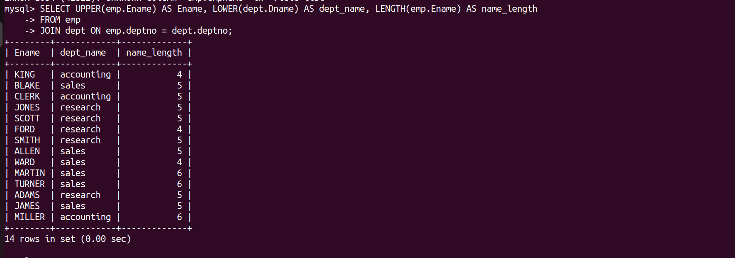
V.

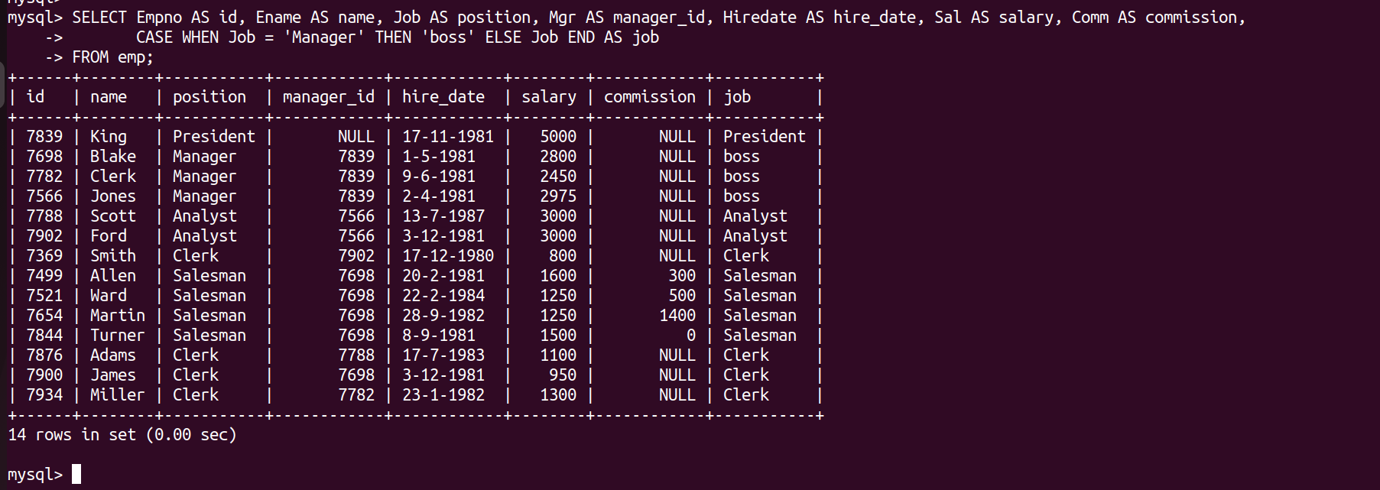
=======================================================================

Q2. ON TABLES
I.
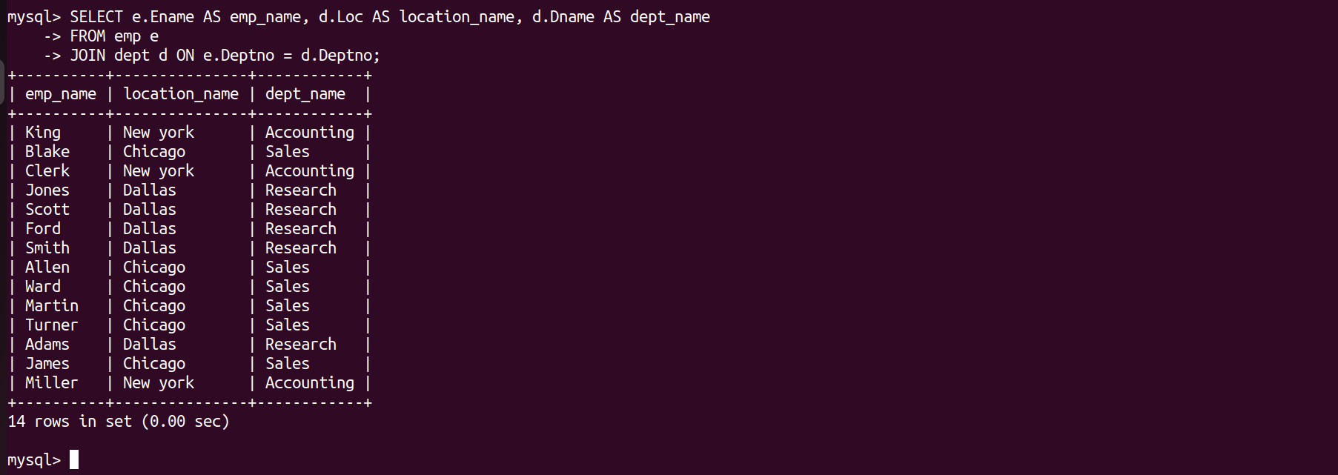
II.
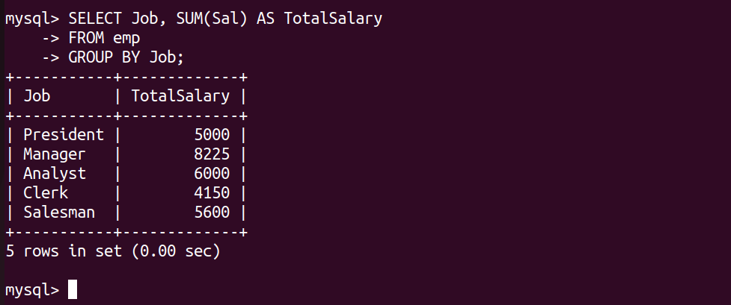
III.
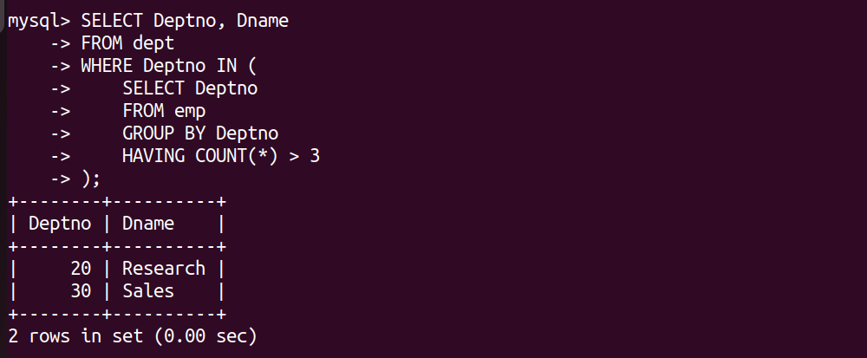
IV.
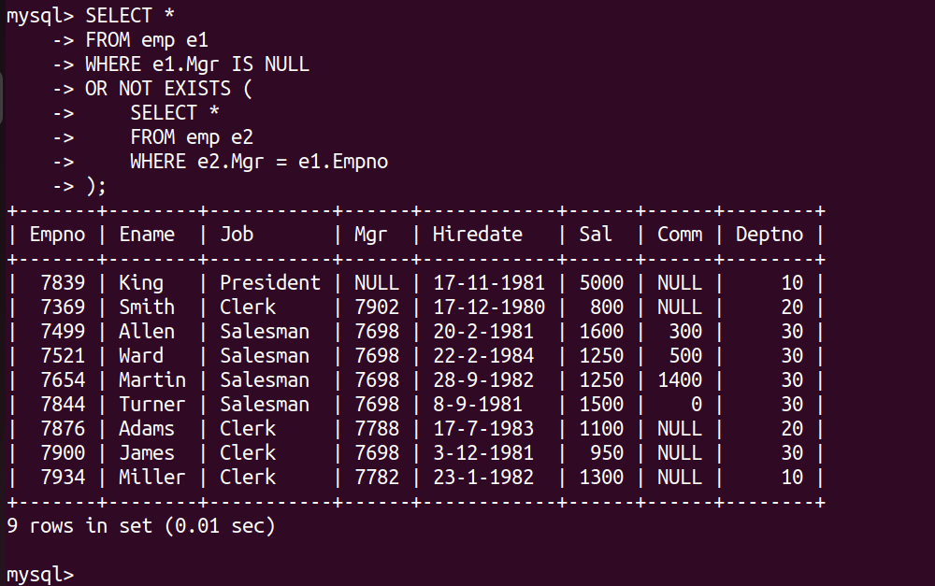

Q3. ON PL-SQL

delimiter &&
CREATE OR REPLACE FUNCTION get_dept_name(p_empno IN emp.Empno%TYPE)
RETURN dept.Dname%TYPE IS
v_dept_name dept.Dname%TYPE;
BEGIN
SELECT Dname INTO v_dept_name
FROM emp
JOIN dept ON emp.Deptno = dept.Deptno
WHERE emp.Empno = p_empno;

RETURN v_dept_name;
END &&
delimiter ;

Q4. TRIGGER

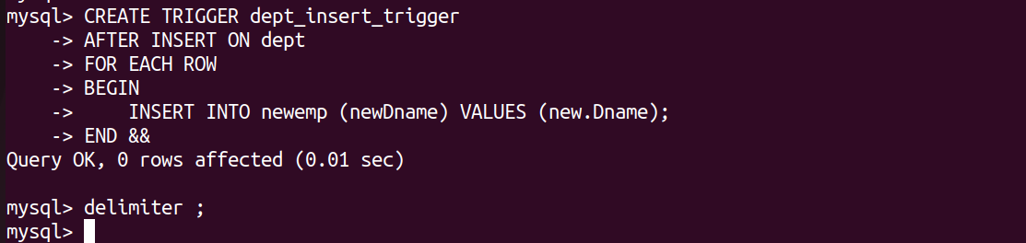
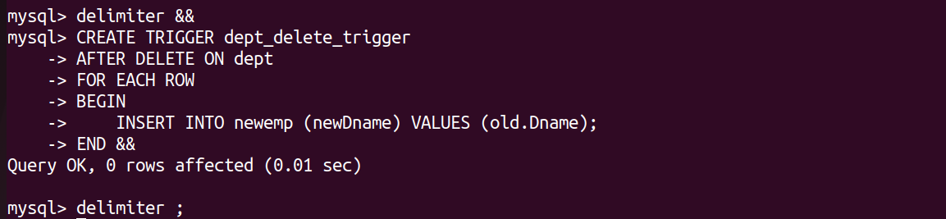
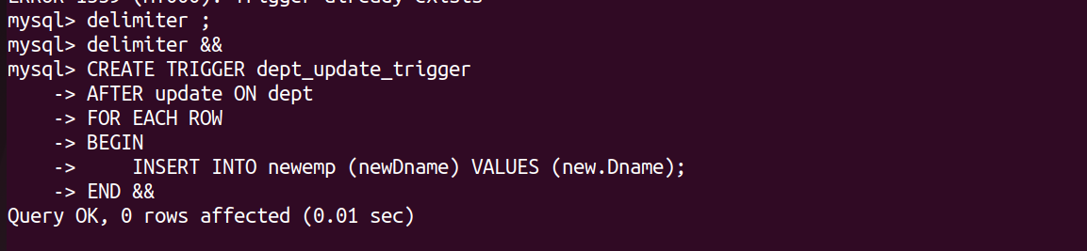

Q5. MONGODB
// Select the database to use.
use('sample_db');

Insert a few documents into the sales collection.
db.getCollection('my_col').insert([
{ 'title': "MongoDB Overview" , 'description': "MongoDB is no SQL database", 'by': "tutorials point", 'url' : "http://www.tutorialspoint.com" , tags: ["mongodb","database","NoSQL"], "likes": 100},
{ 'title': "NoSQL Database" , 'description': "NoSQL database doesn't have tables" , 'by': "tutorials point", 'url' : "http://www.tutorialspoint.com" , 'tags': ["mongodb","database","NoSQL"], "likes": 20, 'comments':[{user:"user1",message:"My first comment",dateCreated:"new Date(2013,11,10,2,35),like:0"}] }])

1.
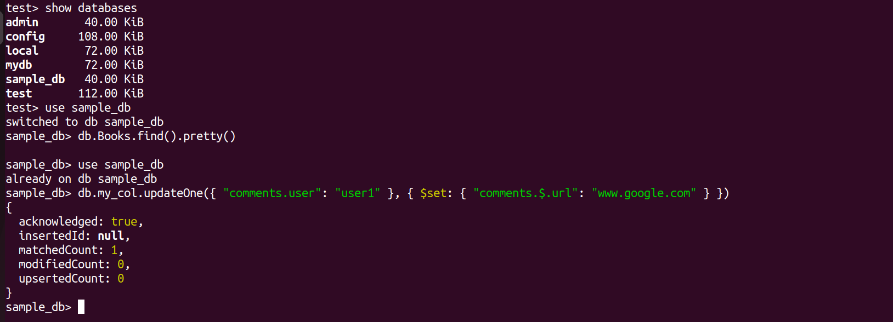

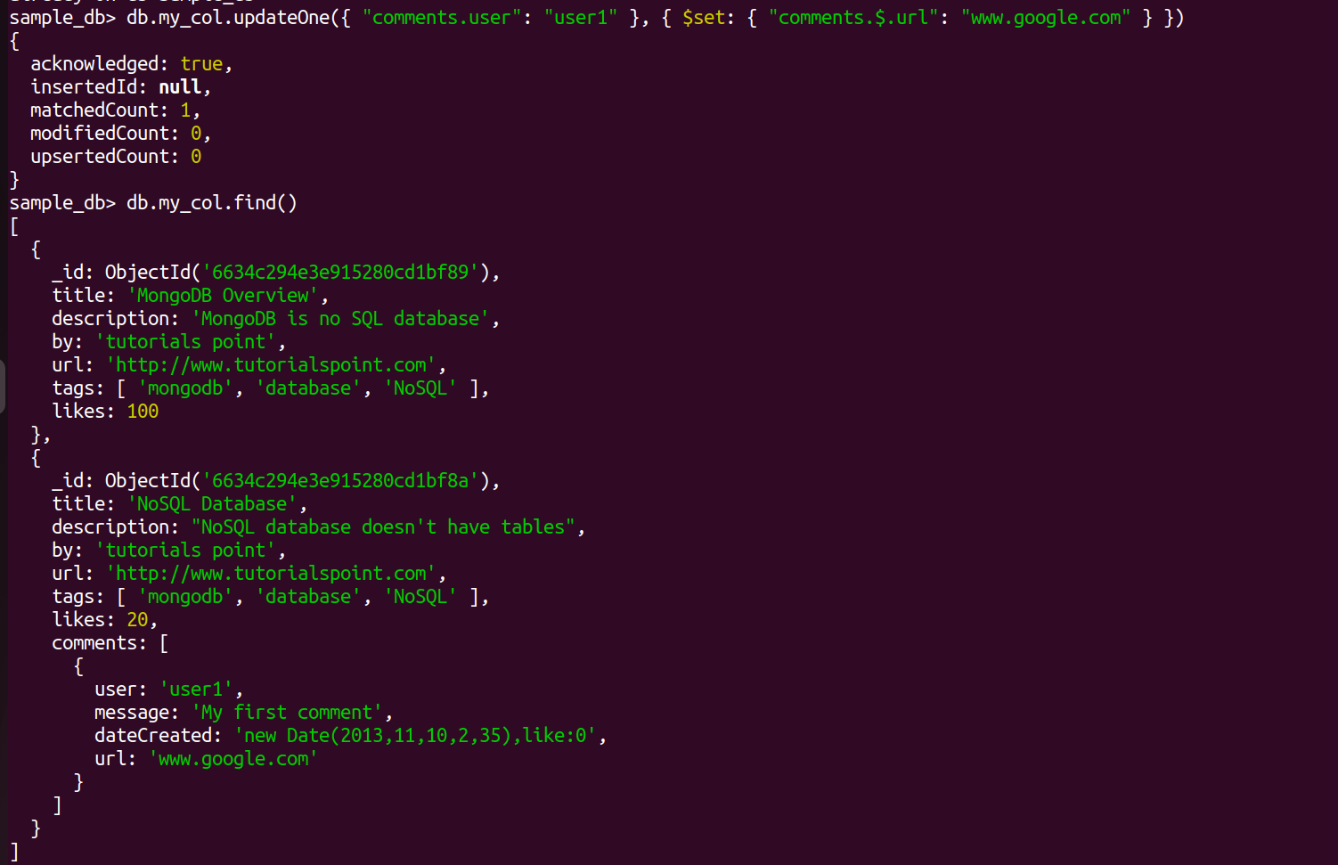

2.
